2: 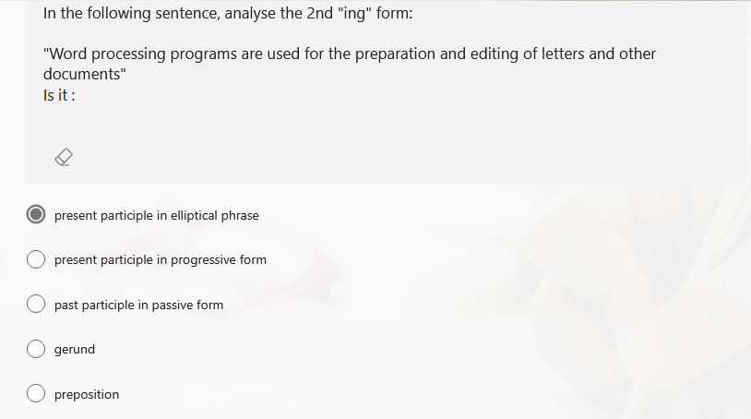
E’ GERUNDIO
3:
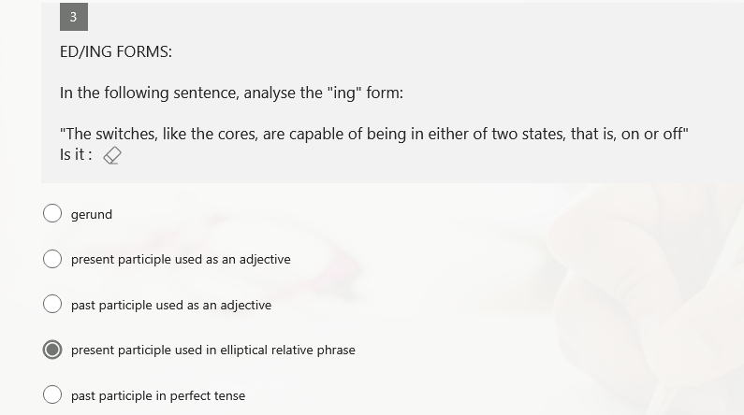
E’ GERUNDIO
4:
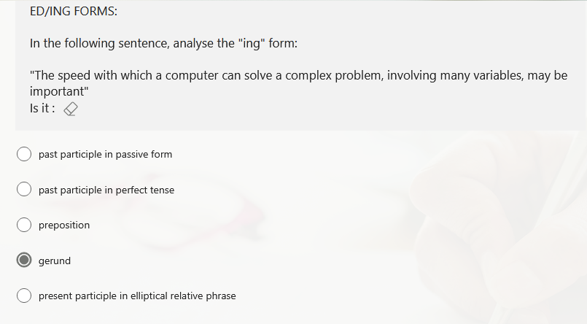
E’ PRESENT PARTICIPLE IN ELLIPTICAL REALTIVE PHASE
5:
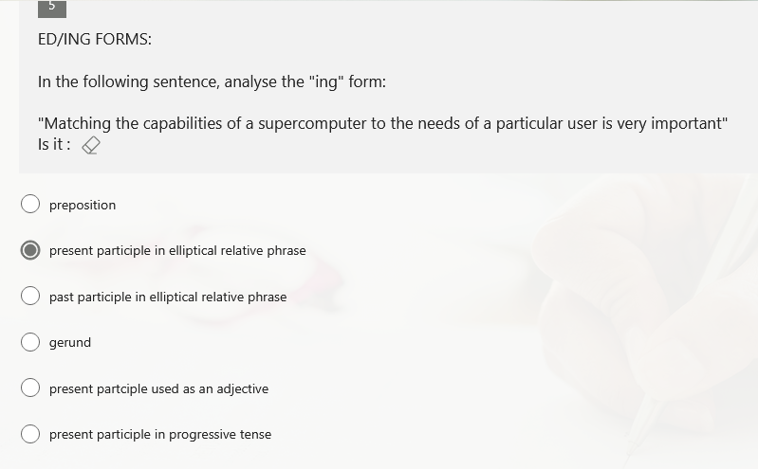
E’ GERUNDIO
6:
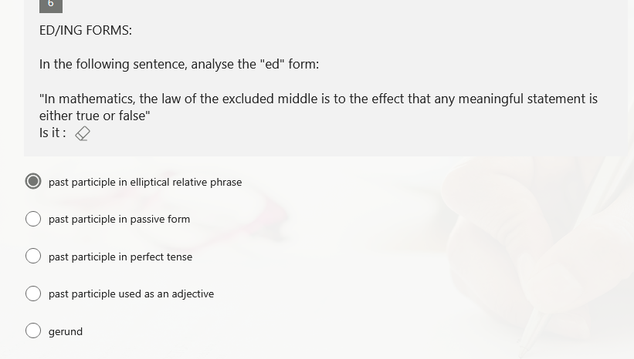
E’ GERUNDIO
9:
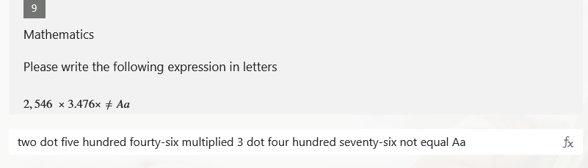
NON E’ DOT, E’ TWO THOUSAND FIVE HUNDREAD ECC…
10:
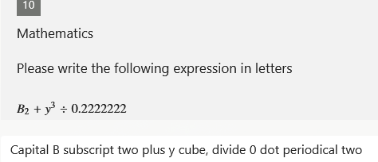
Questa è la versione corretta, e non B subscript two add ecc…
13:
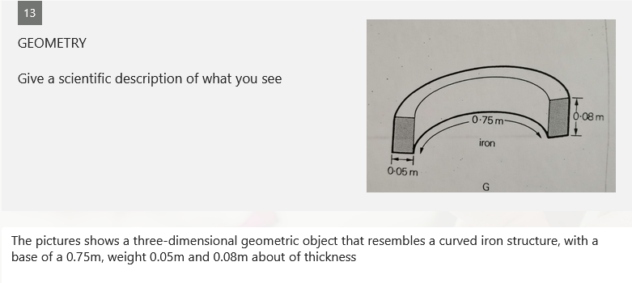
NO
Correct answere: “ The figure G is a curve with hight at 0.08m, thickness of 0.05m and the lenght of 0.75m. This is a semi circle.”
“Va bene anche qualcosa di simile”
14:
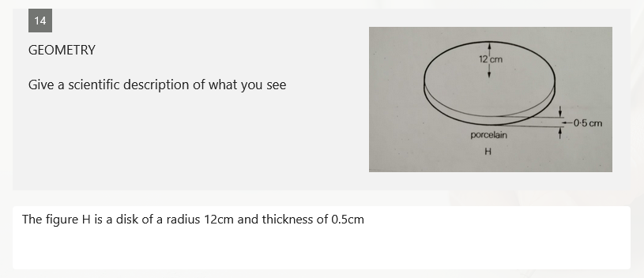
This is the correct answare

